Name: Arpit Mahalle
React Assignment 2(Day11)

Output screenshots
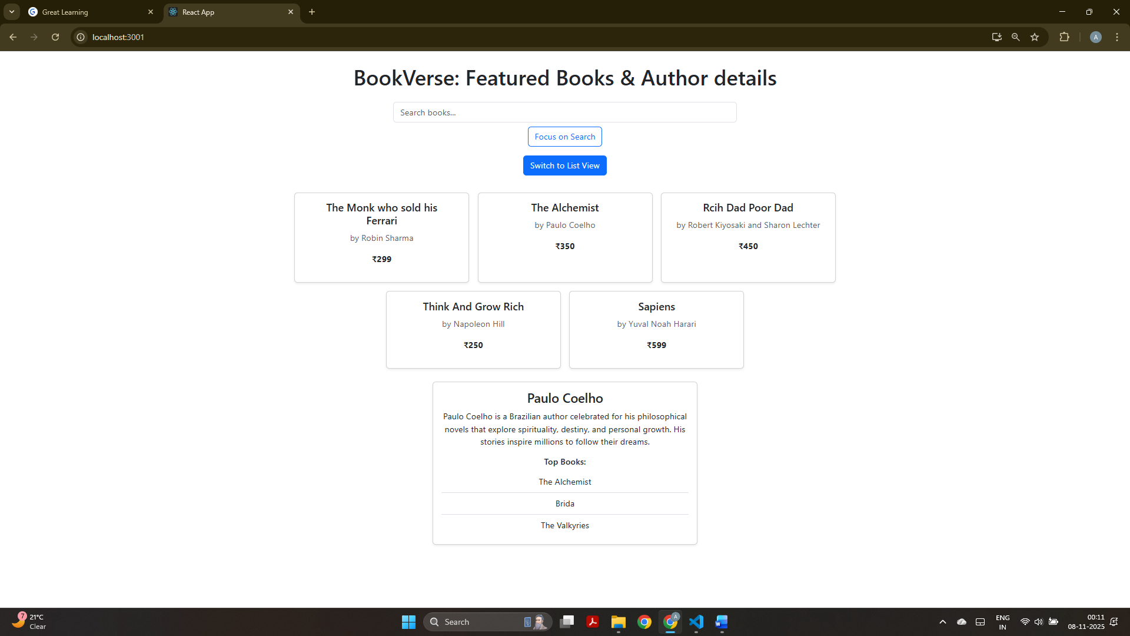
This screenshot displays the grid view with featured list of books with their authors and a small description of author’s bio and top 3 books loaded below.

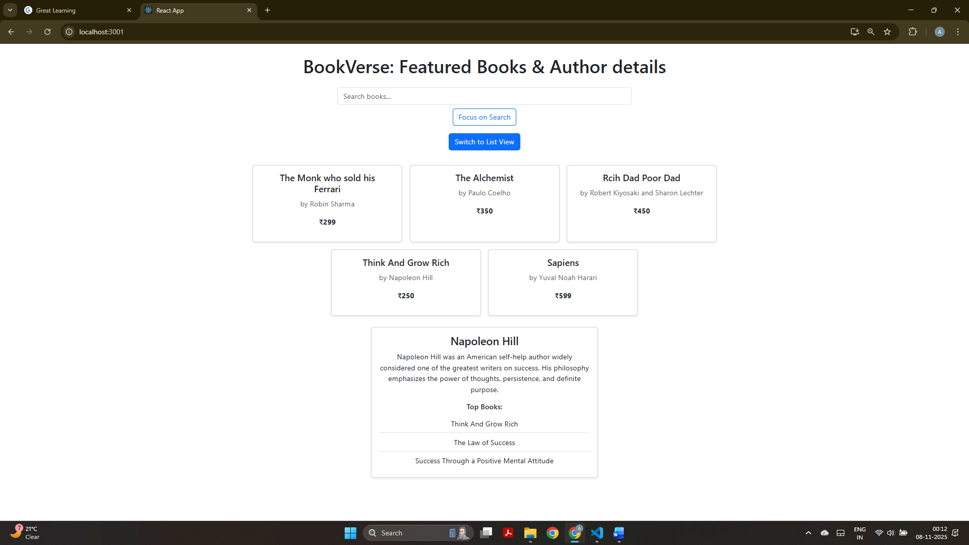
It also displays the grid view with author Napoleon Hill’s bio and top 3 books when clicked on “Think And Grow Rich” cardbox.

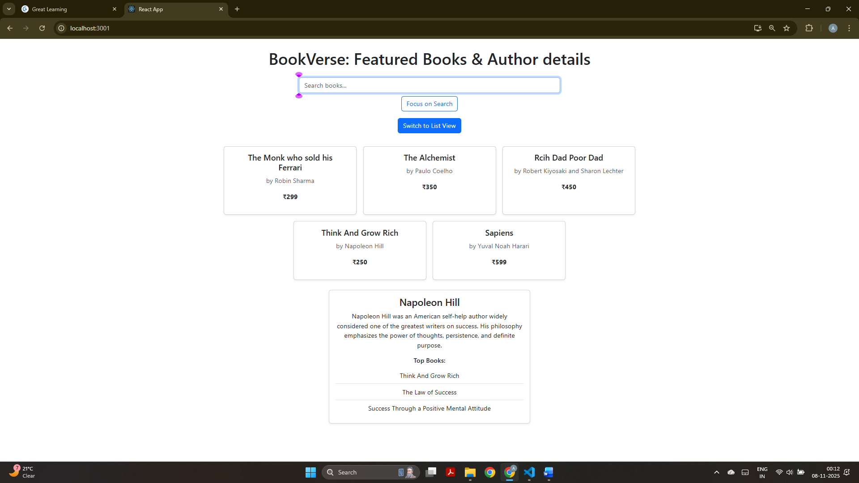
This screenshot displays the ref functionality, where “Focus on Search” button shows the focus on search box.

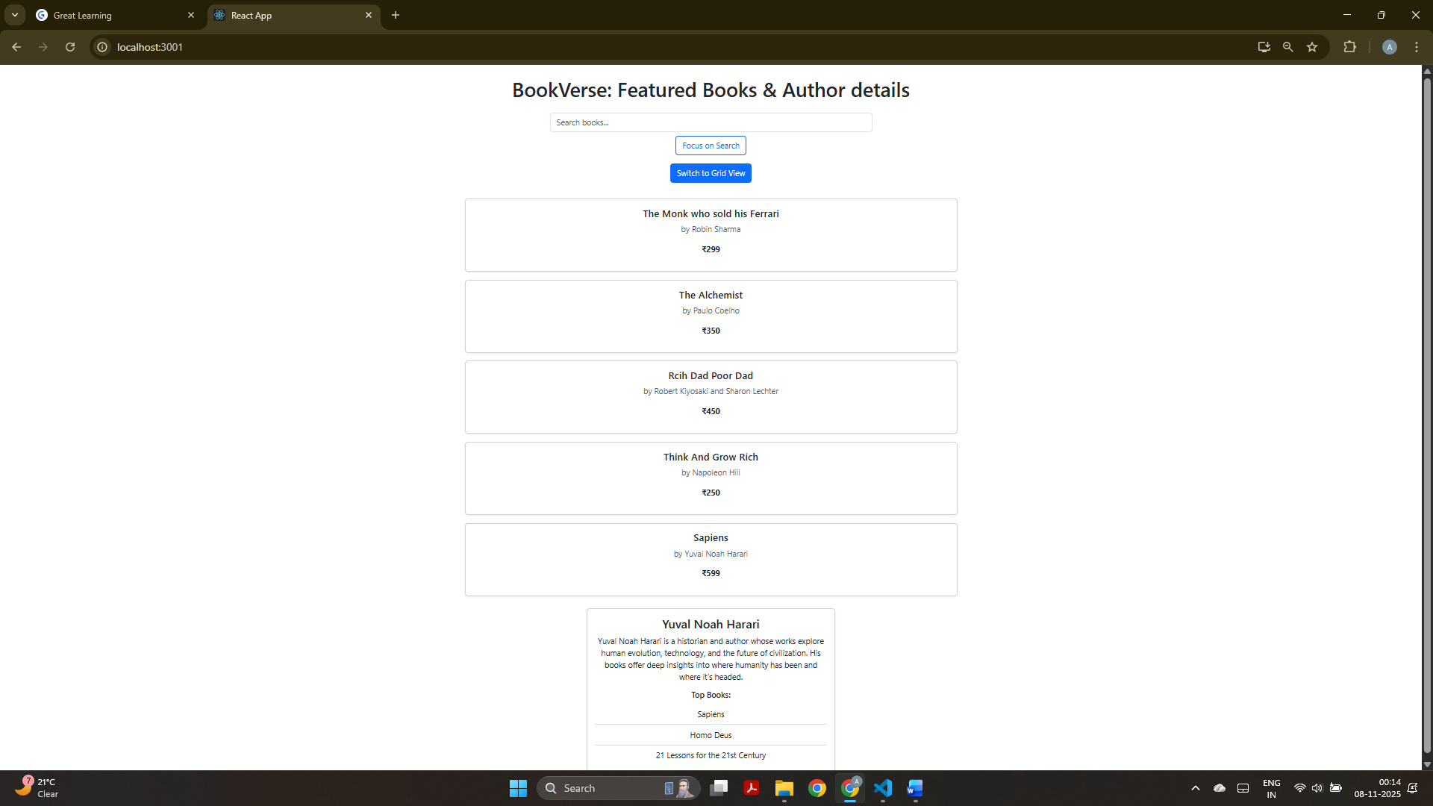
This screenshot displays the featured books and author details in list view with author info loaded when clicked on that cardbox.

